MY REVISION TIMETABLE
NAME:____________________YR GROUP:__________________

Guidance before you start:
- Start your revision timetable by writing down your exam dates (if available)
- List all of the subjects that you do and break them down into sub-categories – e.g. English Literature may be broken down into the different books you are studying and then further into chapters/themes/quotes etc.
- Decide what type of revision you will have for each slot. Be as specific as possible: e.g.: Maths Paper 1 -exam practice or Maths Paper 2 – red topics on Hegarty – French: Memrise vocab practice
- You could choose to colour code them if that helps you.
- Mix your subjects up – don’t do all of your worst subjects on the same day!
- Decide which things you only need a short time on and which things you need to look at for longer or several times. Basically your strengths and weaknesses – look at your PLCs or Topic Lists.
- SRP: Remember that you should have a build up towards your exams: you want to have Short but Regular Practice!
- Make a note of important things such as birthdays, family events etc. It’s ok to make time for them!
- Build in breaks –10 minutes for every hour of work is usually a good rule but if you have a short concentration span maybe 5 minutes every half an hour is better.
- Do a new copy for each week – that way you can cross things off as you go which will give you a sense of accomplishment.

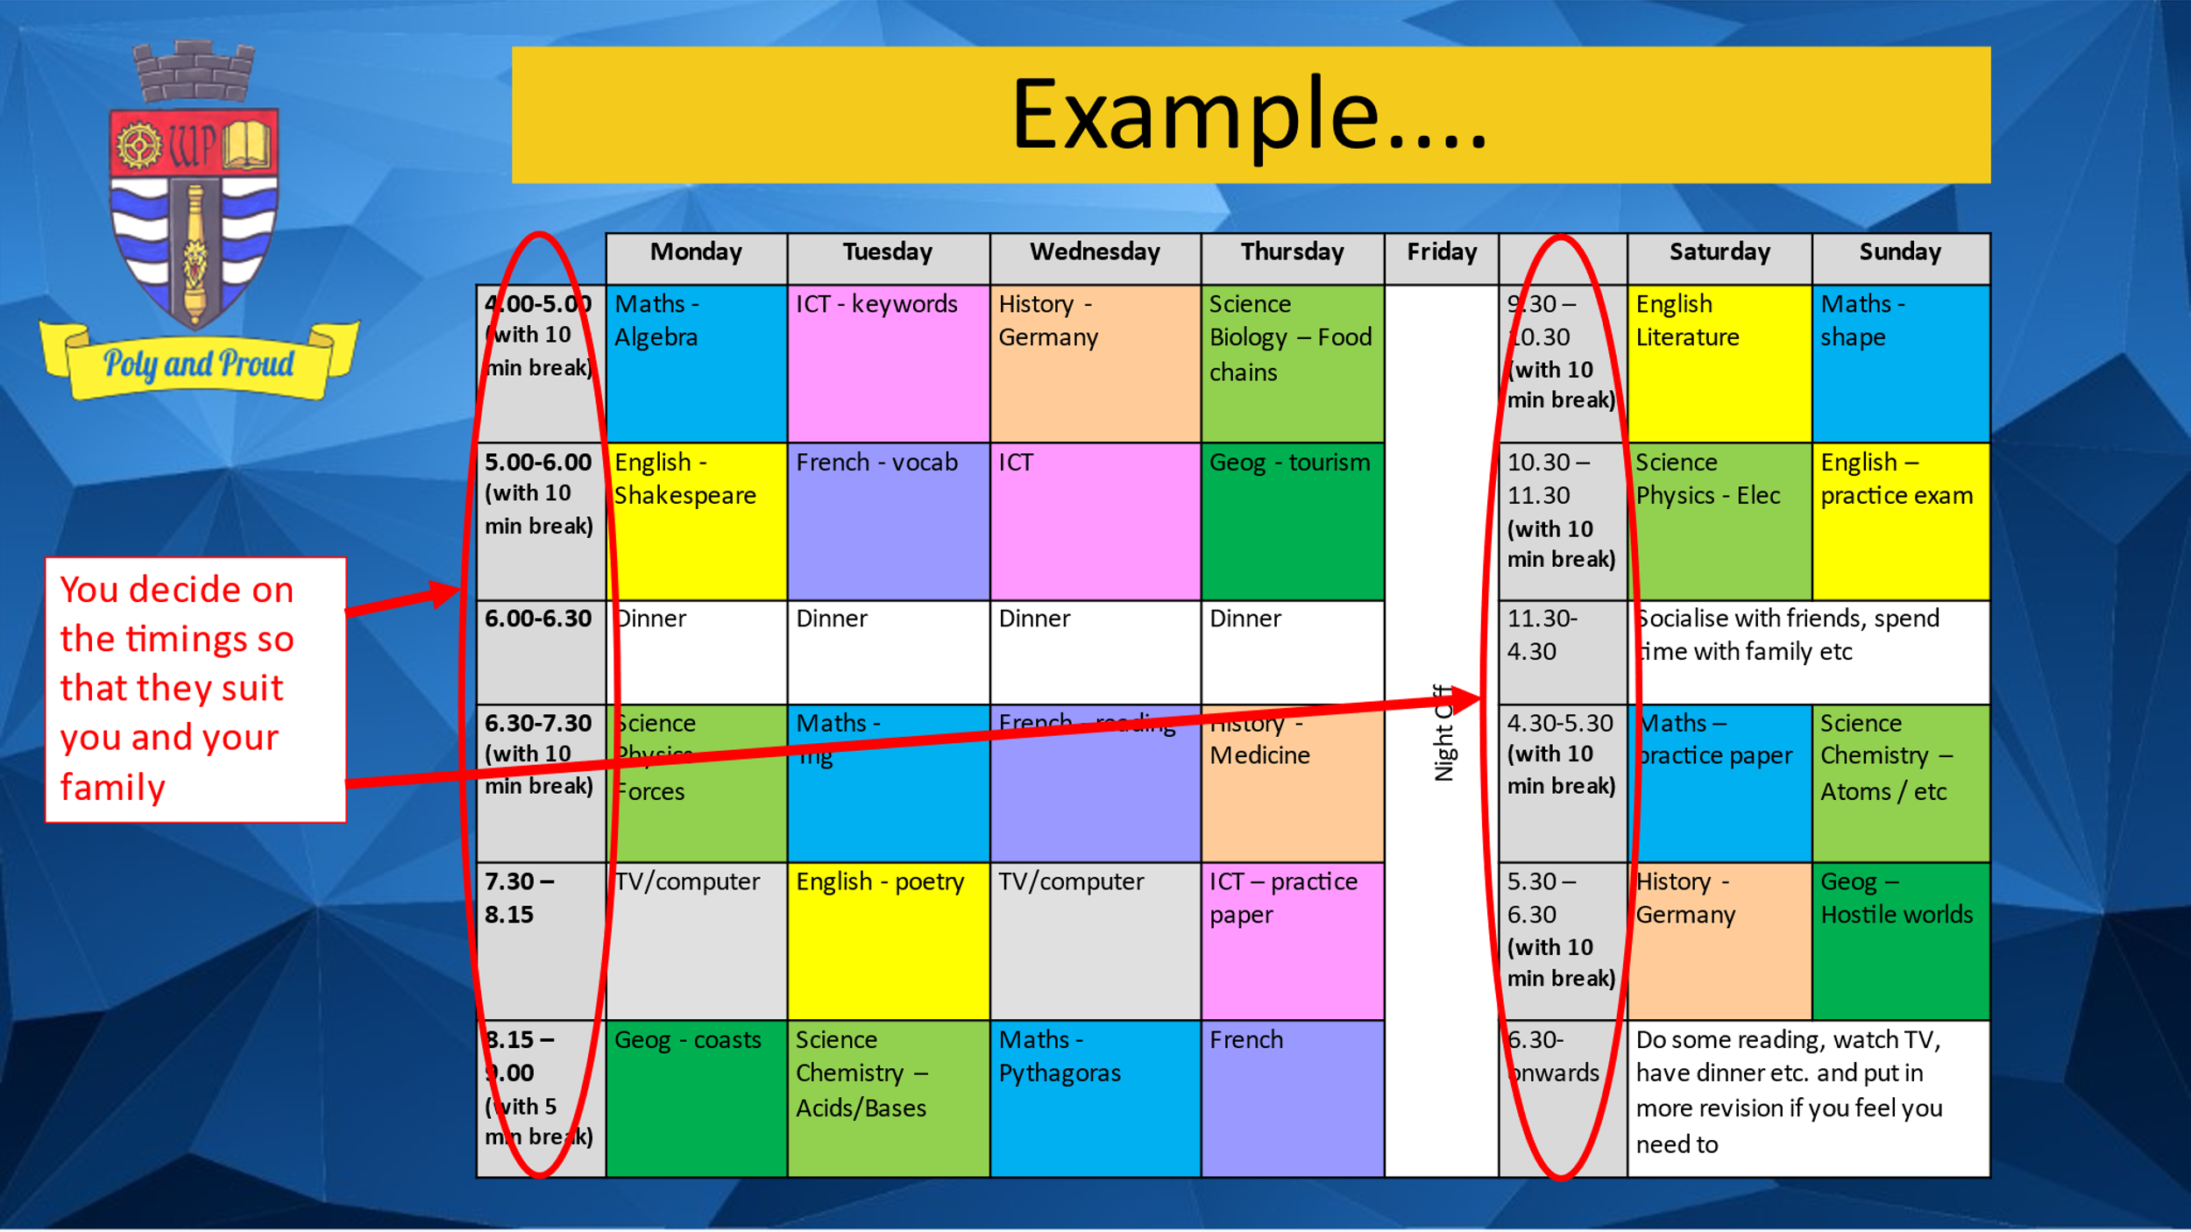

WEEK :_______________________________________________(write the dates for each day of the week)

 | Mon | Tue | Wed | Thurs | Fri |  | Sat | Sun
WEEK :_______________________________________________(write the dates for each day of the week)
 | Mon | Tue | Wed | Thurs | Fri |  | Sat | Sun

WEEK :_______________________________________________(write the dates for each day of the week)

 | Mon | Tue | Wed | Thurs | Fri |  | Sat | Sun
WEEK :_______________________________________________(write the dates for each day of the week)
 | Mon | Tue | Wed | Thurs | Fri |  | Sat | Sun

 | Mon | Tue | Wed | Thurs | Fri |  | Sat | Sun
WEEK :_______________________________________________(write the dates for each day of the week)

WEEK :_______________________________________________(write the dates for each day of the week)

 | Mon | Tue | Wed | Thurs | Fri |  | Sat | Sun
WEEK :_______________________________________________(write the dates for each day of the week)

 | Mon | Tue | Wed | Thurs | Fri |  | Sat | Sun

